Some ideas about data base feature

- The idea:
to have a server that is watching data base.

- First step:
When writing on disk: Save only the data not the whole stuf.
To do that write in a file these normations: page, line, row, pid.
Load data.

-Second step:
When another wants to write at the same time: check this file and parse this file. If address is not the same page line row and pid is not alive then write data in this file if it is not occupied by another process (otherwise wait) and then write data in the data base then reload the data base.

ArgoUML or Umbrello are both Open Source. ArgoUML will be used to do use case diagram.

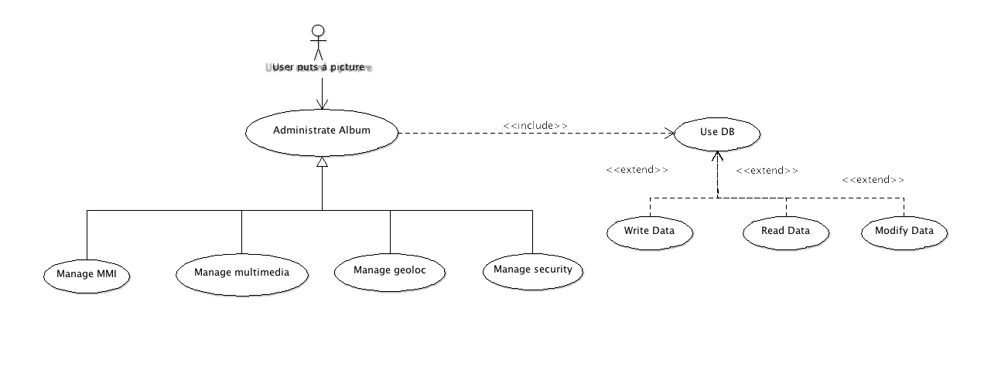
Case diagram features of the album

